The program ‘heatequation.py’ uses the Crank-Nicolson method to solve the heat diffusion problem in a rod where the two ends of the rod are insulated and subject to given boundary conditions. In the figure below (taken from *Elementary Differential Equations and Boundary Value Problems* by Boyce, DiPrima, and Meade), u(x,t) represents the temperature of the bar at location x along the bar and time t in the simulation.

The output of the program is a plot of x against u(x,t), for several timesteps within the simulation. This will graphically show the temperature distribution in the bar at several points in time.

The program accepts these inputs, which determine the initial parameters for the simulation:

L: length of rod  
T: total simulation time  
dx: step size along x-axis  
dt: step size along t-axis  
cond0: x=0 boundary condition  
condL: x=L boundary condition  
bc: string, specifies type of boundary condition  
alpha2: thermal diffusivity of the rod ($α^{2}$)

First, I simulate with a set of arbitrary, “standard” values for the parameters. These are: L = 1.0, T = 0.1 , dx = 0.1, dt = 0.025, cond0 = 0, condL = 0, bc, 'dirichlet', alpha2 = 1.0.

In this plot, the starting temperature of the distribution is red. It has the parabolic shape because I have specified the initial temperature distribution to be sin(πx). As we increase time steps, the entire bar begins to cool, and by t=0.1, the distribution is that of the blue curve. This behavior is expected for a bar where the ends are perfectly insulated, and where we keep the ends at a temperature of 0.0.

Next, I experiment on the same standard rod with varying alpha-squared values. These values are taken from the following table in *Elementary Differential Equations and Boundary Value Problems.*

Silver:

Air:

Water:

The thermal diffusivity of silver is 1.6563, even higher than that of the “standard” rod, which has the arbitrary thermal diffusivity 1.0. This means that the heat quickly diffuses through the rod.

Comparing the plot for a silver bar with the plot for a bar of air, the change in heat distribution over the same time duration is much more dramatic for the silver bar.

The thermal diffusivity of water is 0.00144, which is much lower than that of both silver and air. For this reason, there is essentially no difference in temperature distribution between the start and end of the simulation.

For water, changes can be observed over a much longer simulation duration. The following plot simulates a water bar for T = 10.0, with timesteps of size 2.0.

Whereas with the other materials, changes could be observed within a time interval of T = 0.1, water has much lower thermal diffusivity.

Now I alter the rod length and compare the results to the “standard” rod, which has length L = 1.0m.

L = 2.0

L = 4.0

L = 10.0

The sinusoidal behavior is due to the initial temperature distribution function being sin(πx), which is arbitrarily specified to give us something to look at. This means that when I double the rod length, we can observe a full period of the sine function. The same explains what happens when I lengthen the bar to 4.0 and 10.0 meters.

In all of these longer bars, we observe that the temperature distribution has decreasing amplitude at every timestep. This is consistent with what I would have expected; as time goes on, the temperature stabilizes to the temperature at which I maintain the ends.

In all the previous experiments, I used Dirichlet boundary conditions with each end maintained at 0 degrees Celsius. What if I vary the boundary conditions?

Again looking at Dirichlet boundary conditions, I will alter the values. (For these plots, I set dx = 0.01 so that the curves appear smoother.)

cond0 = 50.0, condL = 0.0

cond0 = 50.0, condL = 50.0

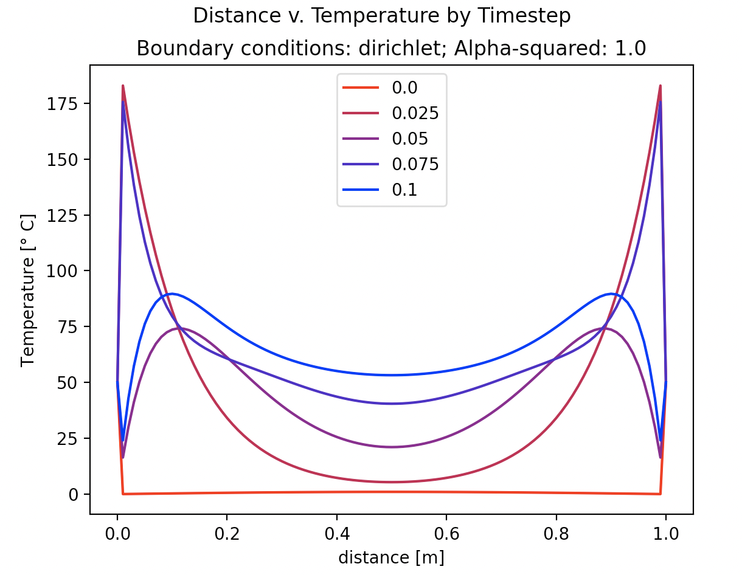

cond0 = -50.0, condL = -50.0

In the first plot, I set the left end to 50 degrees, while keeping the right end to 0 degrees. The sinusoidal behavior is not as clear now that the two ends are at different temperatures, but this behavior is still reflected in the rising and then falling temperature as we move from left to right along the bar. The red curve in particular represents the initial temperature distribution, and we can see that the left end is 50 degrees, and it quickly drops off and goes to 0 as we move right along the bar.

The second plot has both ends maintained at 50 degrees. Starting with the red plot, we see that two ends are 50 degrees, and the rest of the bar is 0 degrees to start. As time passes, the heat distributes and the temperature of the middle portion of the bar rises from 0 and gets closer to 50 degrees.

A very similar thing happens when both ends are kept at -50 degrees, but in the reverse direction. The middle of the bar gets colder as time goes by.

Now that I have explored the Dirichlet conditions, we can explore some Neumann boundary conditions. (For these plots, I set dx = 0.01 so that the curves appear smoother.)

Standard case:

cond0 = 0.0, condL = 0.0

The standard case is where I set cond0 and condL to 0.0, which is to say that the heat flux (derivative of temperature) at the boundaries is 0, meaning there is perfect insulation. Notice that the plot is the same as the case of Dirichlet boundary conditions where the temperature at each end is set to be 0, and we simply assume perfect insulation at the ends.

Next, I consider a case where heat flux is positive at each end, and it is clear that near the boundaries, temperature changes more quickly. Near x=0, temperature exhibits a drastic increase, and near x=L, it exhibits a drastic decrease.

cond0 = 2.0, condL = 2.0

Now I consider a negative heat flux at the boundaries.

cond0 = -2.0, condL = -2.0

Near x=0, there is a sudden drop in temperature, and near x=L there is a sudden increase.

Although adjustments to heat flux at the boundaries affects temperature behavior near the ends, the overall stabilization of temperature over time seems to be unaffected.